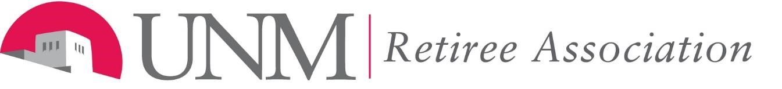

UNMRA BOARD OF DIRECTORS Special MEETING with Legislative Committee
Monday, July 2, 2018, 2:00 PM – 3:00 PM
STUDENT SUPPORT AND SERVICES CENTER

UNIVERSITY BLVD. SE

AGENDA

- Call to Order - Donna Smith

- Educational Retirement Fund and Board:

  - Update – Dub Karnes-Padilla and Pug Burge

  - Plan of Action – Pug Burge and Dub Karnes-Padilla

- Adjourn

