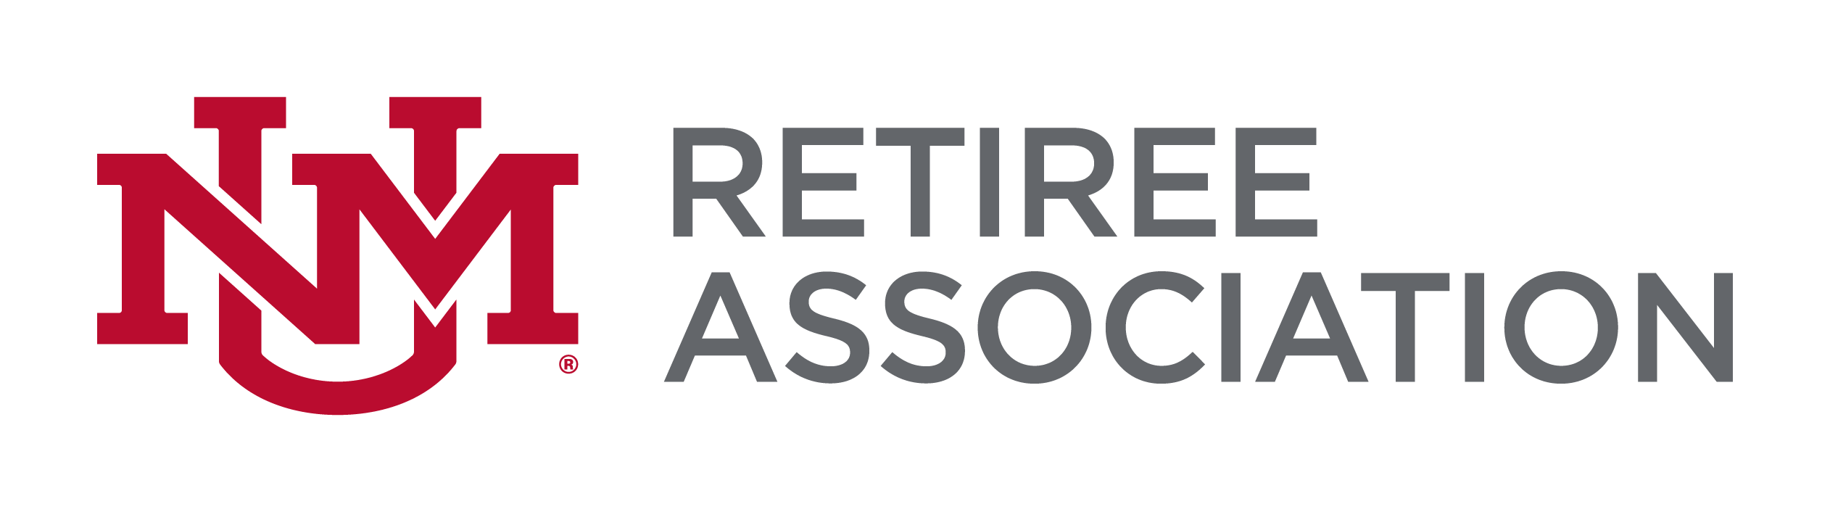
UNMRA BOARD OF DIRECTORS
Tuesday, October 22, 2019, 1:30 PM – 3:00 PM
STUDENT SUPPORT AND SERVICES CENTER
1155 UNIVERSITY BLVD. SE

AGENDA
- Approval of Minutes –August 27th, September 24
- President’s Report:
  - Report on October BOR Meeting
  - Administrative support for UNMRA
  - UNMRA Address/P.O. Box
  - .25 F.T.E. ERB contribution issue
  - Marketing materials
  - Guidelines for list-serve use

- Treasurer’s Report – Jerry White
- Legislative Report – Dub Karnes-Padilla & Breda Bova
- Benefits Report – Leslie Easom
  - FSBC Report – Leslie Easom
- Program Report – Joyce Szabo
- Membership/Communication Report – Mike Dougher & Kevin Malloy

- New Business
- Others

